Wireless Printing: Mobility print
Official URL: https://services.smsu.edu/TDClient/180/Portal/KB/Article/4162/Wireless-Printing-Mobility-print
Category: Knowledge Base > Information Technology Services > Computer, Device, and Printing Support > Wireless Printing: Mobility print
Tags: wireless, printing, iphone, iPad, android
_____________________________________________________

Printing from Personal Devices Using PaperCut Mobility Print
While printing from SMSU issued devices and printing stations is encouraged we also offer the option to print from your own personal devices through PaperCut Mobility Print. Mobility Print simplifies the printing process for bring your own devices (BYOD) and other end-user managed devices, such as smartphones, tablets, laptops or Chromebooks. End users can quickly discover and set up printers on their own, regardless of their operating system or the brand of printer. Mobility Print delivers secure network print services for iOS, Windows, macOS, Android, and Chrome devices. Mobility Print is easy to set up so users can print from their own devices.

Instructions for Printing from your iPhone and iPad
- Step 1: Click on the link below and follow the instructions in the image below to download the papercut profile http://10.10.8.125:9163/setup
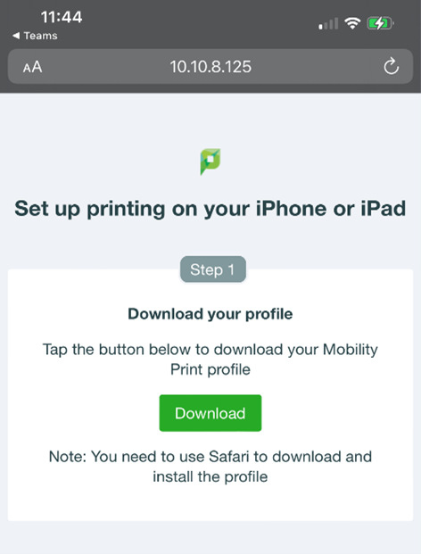
Figure 1: Mobile webpage showing ‘Set up printing on your iPhone or iPad’ with Step 1 to download the Mobility Print profile and a green Download button.
- Step 2: After downloading the papercut profile click allow
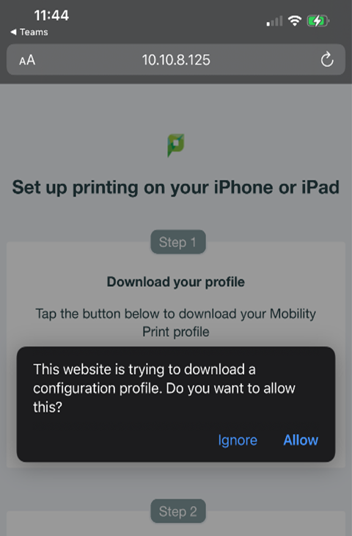
Figure 2: iOS prompt asking to allow download of a configuration profile for Mobility Print, with Allow and Don’t Allow options.
- Step 3: Make your way to “settings” on your iPhone/iPad and click profile downloaded
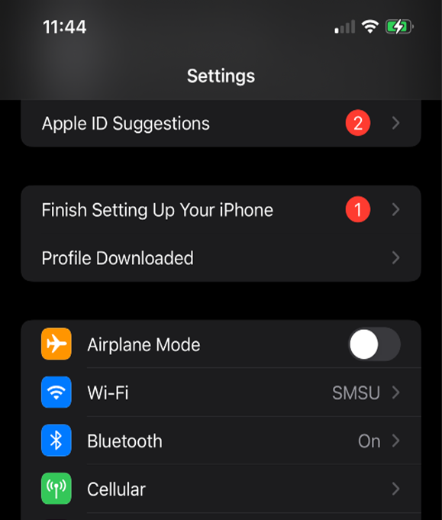
Figure 3: iPhone Settings screen displaying a ‘Profile Downloaded’ notification indicating a new configuration profile is ready to install.
- Step 4: Click on the Profile that say papercut mobility and click install,to complete this process it would require your passcode or password.
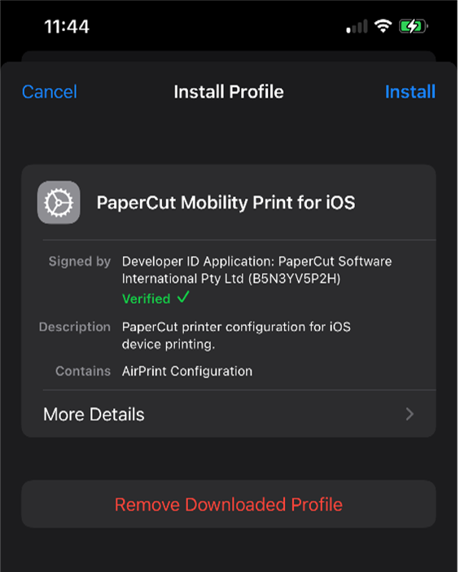
Figure 4: iOS configuration profile screen for ‘PaperCut Mobility Print’ with an Install button at the top to begin installation.
- Step 5: After installing profile, choose what you need to print. After selecting your document, you would need to choose what printer you want to use.
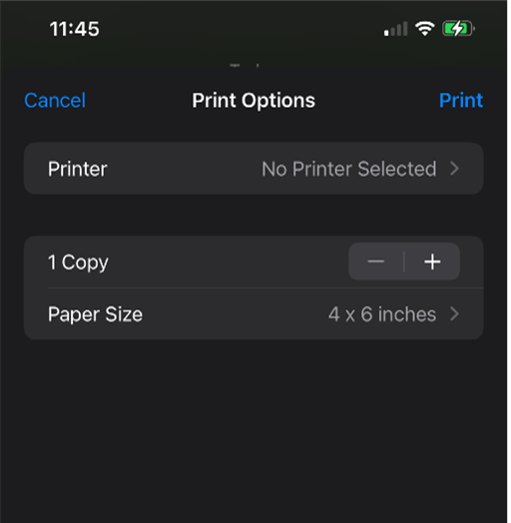
Figure 5: iPhone install profile confirmation screen prompting for passcode or showing options to continue installing the Mobility Print profile.
- Step 6: Select what printer you need to use from the options in the image below
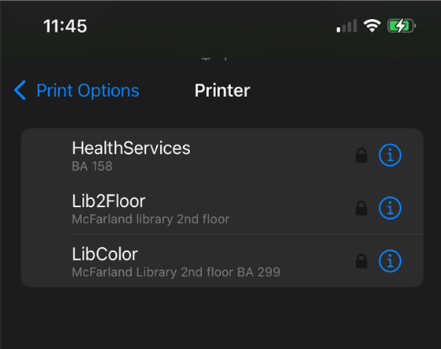
Figure 6: Print options screen on iPhone showing available printers, allowing the user to select a Mobility Print printer.
- Step 7: To sign in you will need to type “Smsu\your star-id” and your star-id password
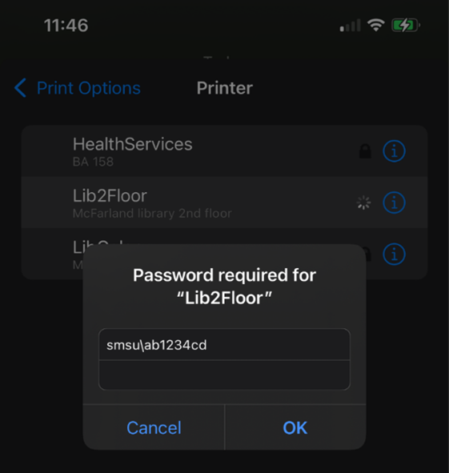
Figure 7: Authentication prompt requesting username in ‘SMSU\StarID’ format and password to access Mobility Print printers.
- Step 8: After entering your password correctly you should be able to print fine, if you are not able to print please make sure you are connected to the SMSU WI-FI.
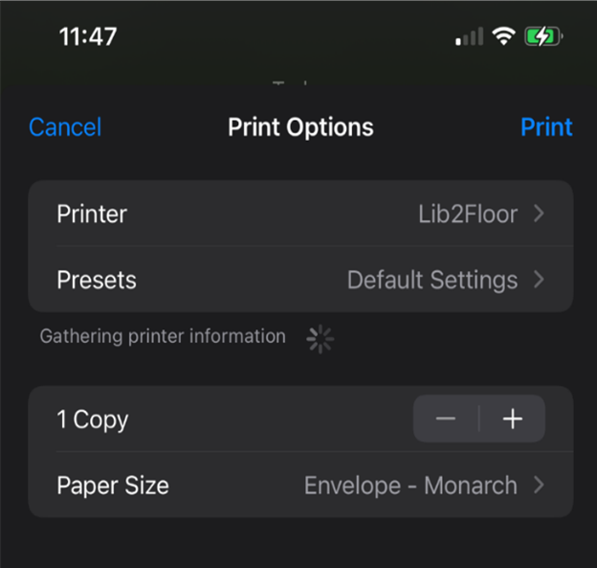
Figure 8: iPhone Print Options screen showing selected printer ‘Lib2Floor,’ default settings, copy count controls, and paper size options while gathering printer information.

Instructions for Printing on your Android devices
- Step 1: Click on the Link below and follow the instructions in the image below to download the Mobility print app. http://10.10.8.126:9163/setup
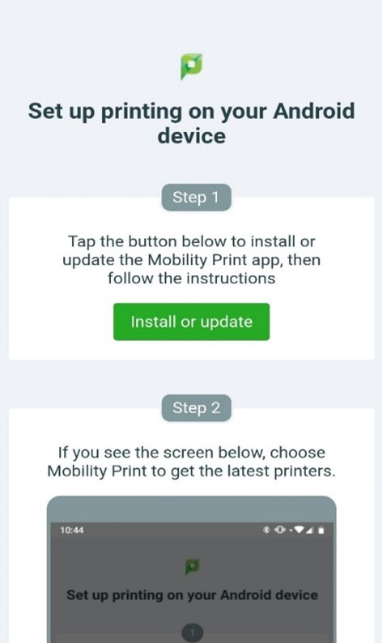
Figure 9: Mobile webpage with link to download the PaperCut Mobility Print app for Android from a setup page.
- Step 2: After installing the Mobility print app click open
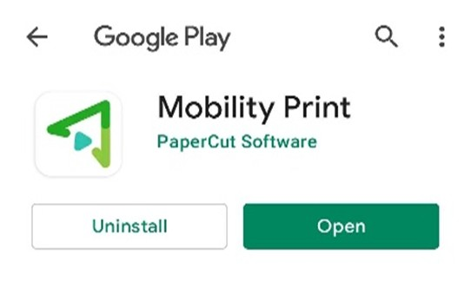
Figure 10: Android device showing Mobility Print app installed with option to open the app.
- Step 3: Follow the instruction in the image below to confirm your mobility printing is on.
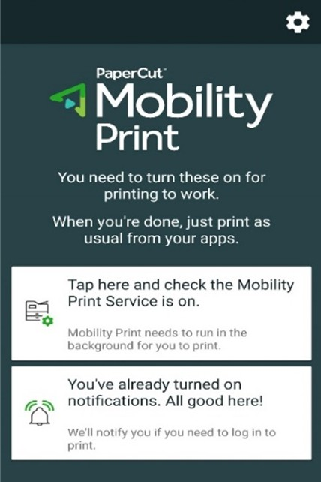
Figure 11: Android printing settings screen showing Mobility Print service with toggle option to enable printing.
- Step 4: This image below represents what icons should be toggled on.
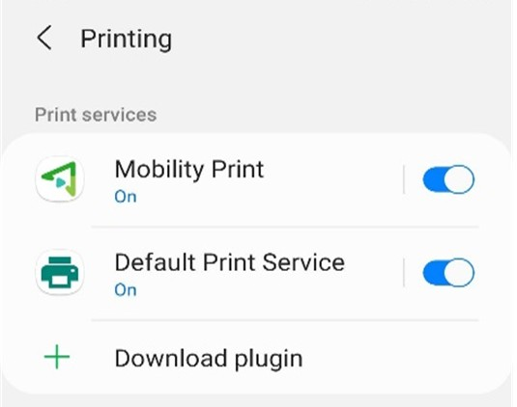
Figure 12: Android settings showing Mobility Print and Default Print Service toggled on for printing support.
- Step 5: Select a document to print, you should get a prompt asking you to sign in. Sign In using the format “SMSU\your star-id” and your star-id password.
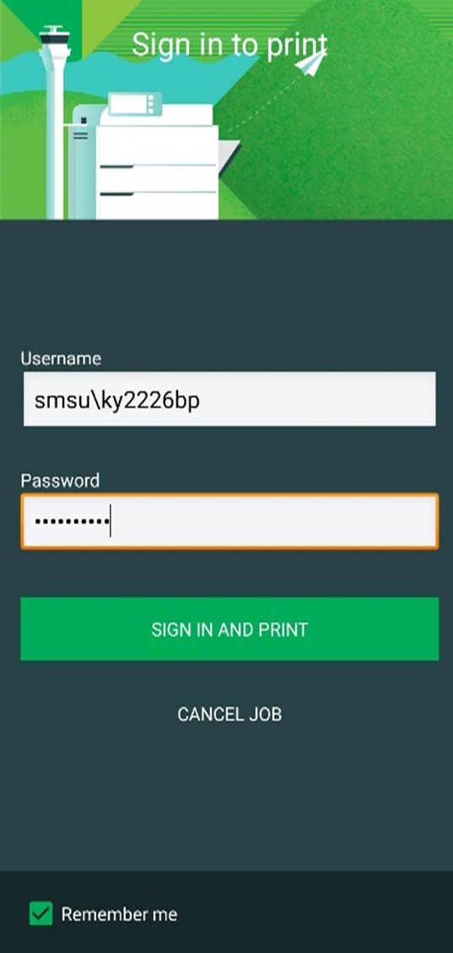
Figure 13: Android print dialog prompting user to sign in using ‘SMSU\StarID’ credentials before submitting a print job.
Accessibility Review & Update Log:
- [x] Content accuracy and link integrity verified
- [x] High-contrast visual hierarchy implemented (Inter and Calibri)
- [x] Image alt-text captions verified (all screenshots captioned)
- [x] PDF attachments scraped and fully inlined directly inside the document
- [x] Outline headers and standard list sequences optimized for screen readers

